RGB Color Model

The RGB color model is one of the most widely used color representation method in computer graphics. It use a color coordinate system with three primary colors:



Each primary color can take an intensity value ranging from 0(lowest) to 1(highest). Mixing these three primary colors at different intensity levels produces a variety of colors. The collection of all the colors obtained by such a linear combination of red, green and blue forms the cube shaped RGB color space.

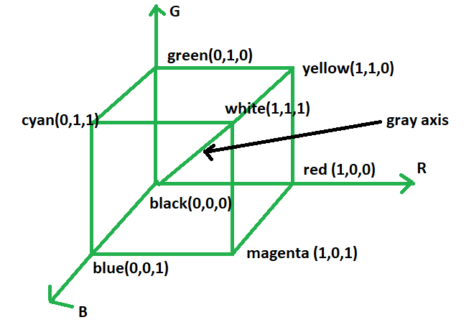

The corner of RGB color cube that is at the origin of the coordinate system corresponds to black, whereas the corner of the cube that is diagonally opposite to the origin represents white. The diagonal line connecting black and white corresponds to all the gray colors between black and white, which is also known as **gray axis**.

CMYK Color Model

If we subtract red from white, what remains consists of green and blue which is cyan. The coordinate system of CMY model use the three primaries’ complementary colors:



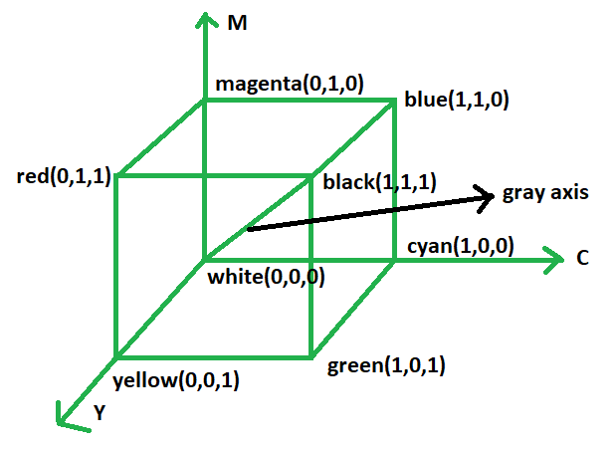

The corner of the CMY color cube that is at (0, 0, 0) corresponds to white, whereas the corner of the cube that is at (1, 1, 1) represents black. The following formulas summarize the conversion between the two color models:

